Project

Sumanth Pasupuleti

2024-03-12

#The dataset contains information about Connecticut Real Estate Sales Data, #including their typeSerial Number

QUESTION 1

To calculate the total number of sales

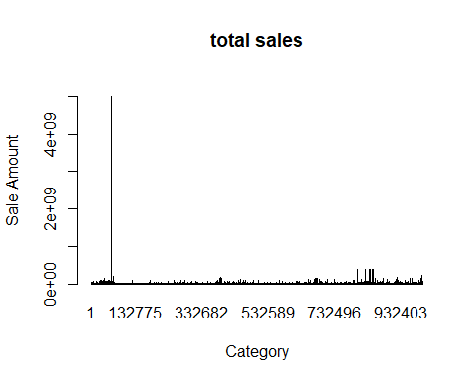

What are the top 5 towns with the highest total assessed value? 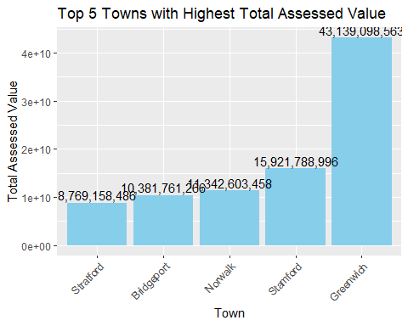

QUESTION 3

identifying key trends in property values across Connecticut

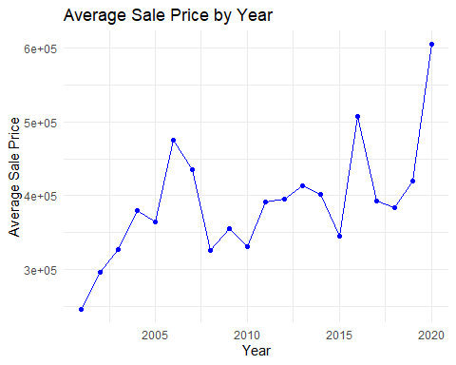

3.1

Calculate average sale price by property type

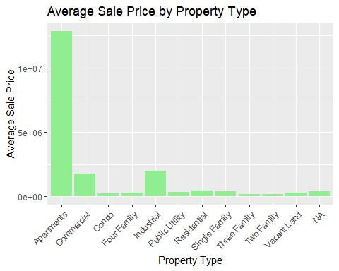

QUESTION 4

Assess the relationship between assessed value and sale amount

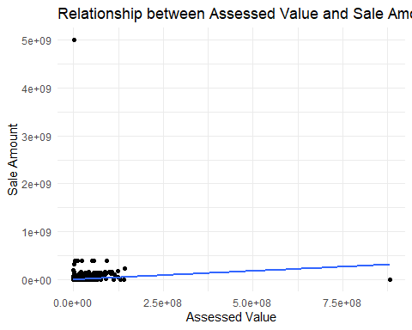

QUESTION 5 Explore the distribution of property types and their impact on values.

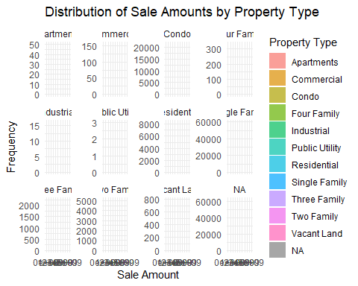

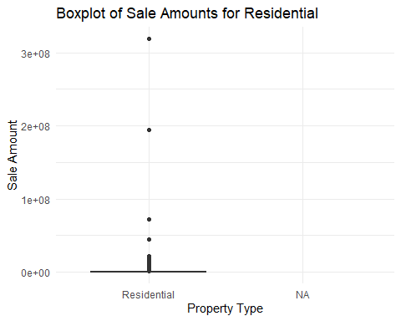

QUESTION 6

Investigate factors influencing property values, including location, amenities, property type, and market conditions.

6.1 Average Sale Price by Year and Property Type 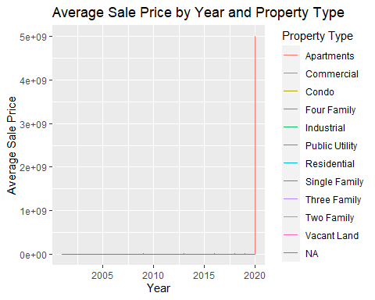

6.2 average sale price by town for different property types 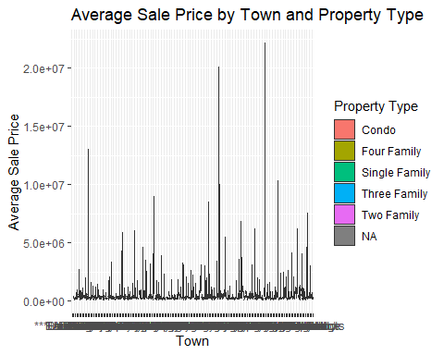

QUESTION 7 The properties with assessed value is more than the sale value

